|  |
| --- |
|  |
| Capstone Project Document |

SUPER SHIPPER SYSTEM

Software Requirement Specification

|  |  |  |
| --- | --- | --- |
| **Super Shipper System** | | |
| **Group Members** | Le Van Quy Hoang | SE90184 |
| Tran Dinh Hoang Huy | SE90201 |
| Nguyen Khac Hoang | SE02564 |
| Kieu Cao Khanh | SE02960 |
| Nguyen Van Quyen | SE02884 |
| Nguyen Thi Hong Nhung | SE02437 |
| **Supervisor** | Mr. Tran Binh Duong | |
| **Project code** | 3S | |

**- Hanoi, 09/2015 -**

TABLE OF CONTENTS

1. FUNCTIONAL REQUIREMENTS 2

1.1. Web application for Admin 2

1.1.1. User Case Diagram 2

1.1.2. Functions 3

*UC- 101: Admin Login* 3

*UC- 103: Admin Change Password* 4

*UC- 104: Admin Forgot Password* 5

*UC- 105: Add Store* 6

*UC- 106: Search Store* 7

*UC- 107:* *View Store’s list* 7

*UC- 108:* *Block store* 8

*UC- 109:* *View Store’s details* 9

*UC- 110:* *Send message to Store* 9

*UC- 111:* *Confirm Store’s payment* 10

*UC- 112:* *View exchange history of Store* 11

*UC- 113:* *Add Shipper* 12

*UC- 114:* *View Shipper’s list* 12

*UC- 115:* *View Order’s list* 13

*UC- 117:* *Search Shipper* 14

*UC- 117:* *Search Order* 14

*UC- 118:* *View Shipper’s profile* 15

*UC- 119:* *View Order’s profile* 16

*UC- 120:* *Update Shipper* 16

*UC- 121:* *Update Shipper* 17

*UC- 122:* *Add new Order* 18

*UC- 123:* *Print bill* 19

*UC- 124:* *Assign Task* 19

1.2. Web application for Store 21

1.2.1. User Case Diagram 21

1.2.2. Function 21

*UC-201:* *Register* 21

*UC-202:* *Login* 23

*UC-203:* *Logout* 24

*UC-204:* *Change password* 25

*UC-205:* *Forgot password* 26

*UC-206:* *View profile* 27

*UC-207:* *Edit profile* 27

*UC-208:* *Create order* 28

*UC-209:* *View order’s list* 30

*UC-210:* *Search orders* 30

*UC-211:* *Cancel order* 31

*UC-212:* *Edit Order* 32

*UC- 213:* *Order’s details* 33

*UC-214:* *View analysis* 33

*UC-215:* *View notifications* 34

*UC-216:* *Rate shipper* 34

*UC-217:* *Send feedback* 36

1.3. Mobile application for Shipper 37

1.3.1. User Case Diagram 37

1.3.2. Function 38

*UC-301:* *Login* 38

*UC-302:* *Logout* 38

*UC-303:* *Forgot password* 39

*UC-304:* *Change password* 40

*UC-305:* *View Profile* 41

*UC-306:* *Update Profile* 41

*UC-307:* *Confirm Code* 42

*UC-308:* *Grab order* 43

*UC-309:* *View orders list* 44

*UC-311:* *UC-311* 44

*UC-312:* *Find best way* 45

*UC-313:* *Send issue’s information* 46

*UC-315:* *View history* 47

*UC-314:* *Change working status* 48

**ACRONYMS & ABBREVIATIONS**

| Abbreviations | Description | Note |
| --- | --- | --- |
|  |  |  |
|  |  |  |
|  |  |  |
|  |  |  |
|  |  |  |
|  |  |  |
|  |  |  |
|  |  |  |
|  |  |  |
|  |  |  |
|  |  |  |
|  |  |  |
|  |  |  |
|  |  |  |
|  |  |  |
|  |  |  |
|  |  |  |
|  |  |  |
|  |  |  |
|  |  |  |
|  |  |  |
|  |  |  |
|  |  |  |

# 1. FUNCTIONAL REQUIREMENTS

## 1.1. Web application for Admin

### 1.1.1. User Case Diagram

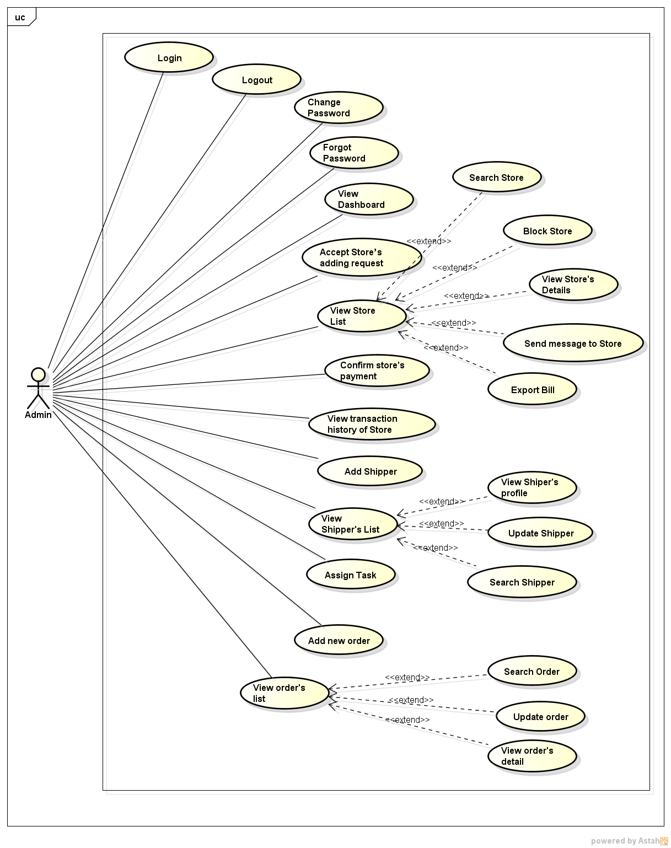

*Figure 11: User case diagram of Web Application for Admin*

### 1.1.2. Functions

###### *UC- 101: Admin Login*

*UC- 102: Admin Logout*

###### *UC- 103: Admin Change Password*

###### *UC- 104: Admin Forgot Password*

###### *UC- 105: Accept Store*

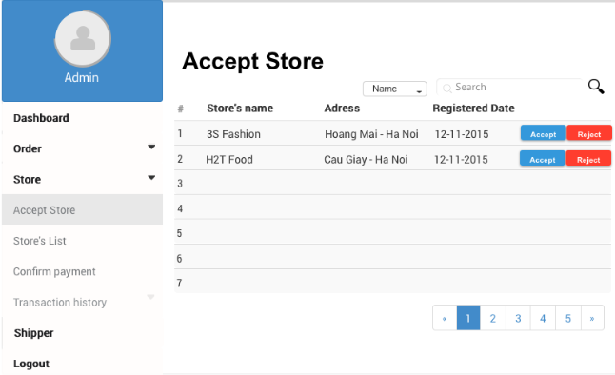

*Figure 11: Screen of Confirm Store’s Adding Request Use case*

|  |  |  |  |  |
| --- | --- | --- | --- | --- |
| **Use Case ID:** | | UC-105 | | |
| **Use Case Name:** | | Accept Store’s adding request | | |
| **Created By:** | | HoangNK | **Last Updated By:** | HoangNK |
| **Date Created:** | | 19/09/2015 | **Date Last updated:** | 24/09/2015 |
| **Actor:** | | Admin | | |
| **Description:** | | If the Store registers to system, an adding request is sent to Admin, after that Admin views list of adding request of the Store then accept or reject to add the Store | | |
| **Triggering Event:** | | Admin wants to accept or reject adding request of Store | | |
| **Preconditions:** | | Admin logged in to system | | |
| **Post conditions:** | | New Store is added to database | | |
| **Priority:** | | High | | |
| **Frequency of Use:** | | Sometime | | |
| **Main flow** | | | | |
| Step | Actor | Action | | |
|  | Admin | Click “Store” button in left navigate bar | | |
|  | System | Display “Store” menu includes: Accept Store, Store’s List, Confirm Payment and Transaction History | | |
|  | Admin | Click “Accept Store” button | | |
|  | System | Load data of Store's Adding Request and display in “Accept Store” screen includes:   * Search textbox and button * Filter drop-downlist * Registered Store’s basic information with 2 buttons “Accept” and “Reject” in each row in a table | | |
|  | Admin | Click “Accept” button to accept to add new Store | | |
|  | System | Display confirm popup includes “Yes” and “No” button | | |
|  | Admin | Confirm by clicking “Yes” button | | |
|  | System | Close popup and hide this store from list | | |
|  | System | Add new Store to database of System | | |
| **Alternative Flows:** | | N/A | | |
| **Exceptions:** | | | | |
| EC1 | At step 5, Admin reject by clicking “Reject” button | | | |
| Step | Actor | Action | | |
| 5.1 | System | Delete this store from list and this Store isn’t added to System | | |
| EC2 | At step 7, Admin click on “No” button | | | |
| Step | Actor | Action | | |
| 7.1 | System | Close popup and proceed to step 4 | | |
| EC3 | At step 4, system can’t get data from database because the internet or the database disconnect | | | |
| Step | Actor | Action | | |
| 4.1 | System | Show error message: “Failed to load data” | | |
| **Includes:** | | N/A | | |
| **Special Requirements:** | | N/A | | |
| **Notes and Issues:** | | N/A | | |

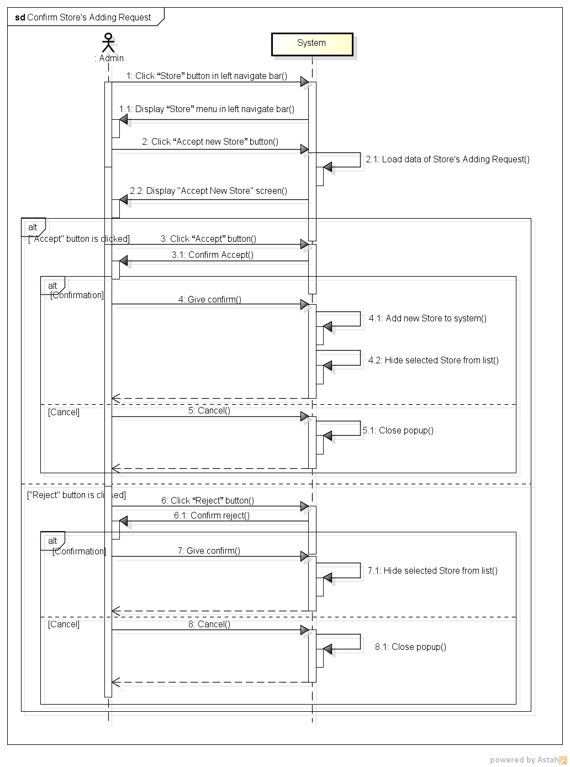

*Figure 11: Sequence Diagram for Confirm Store’s Adding Request Use case*

###### *UC- 106: Search Store*

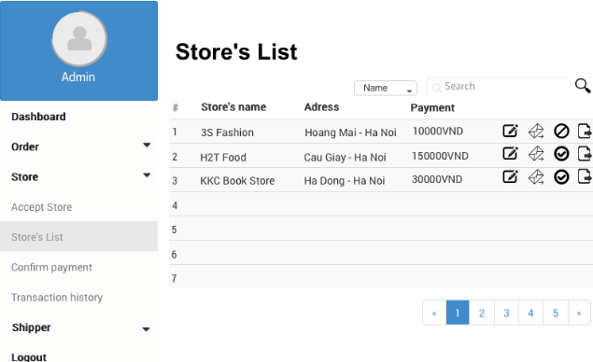

*Figure 11: Screen of Search Store Use case*

|  |  |  |  |  |
| --- | --- | --- | --- | --- |
| **Use Case ID:** | | UC-106 | | |
| **Use Case Name:** | | Search Store | | |
| **Created By:** | | HoangNK | **Last Updated By:** | HoangNK |
| **Date Created:** | | 19/09/2015 | **Date Last updated:** | 24/09/2015 |
| **Actor:** | | Admin | | |
| **Description:** | | Admin wants the system to list all Stores related to a specific keyword and type, after that, Admin can choose a Store to view details, update information and block or unblock this Store. | | |
| **Triggering Event:** | | Admin wants to search store | | |
| **Preconditions:** | | Admin is in view store’s list page ( refer case UC-107 ) | | |
| **Post conditions:** | | Display Store as result of search | | |
| **Priority:** | | High | | |
| **Frequency of Use:** | | Always | | |
| **Main flow** | | | | |
| Step | Actor | Action | | |
|  | Admin | Choose type of searching: Name, Address or Type | | |
|  | Admin | Enter text to “Search” text box | | |
|  | Admin | Click “Search” button or press “Enter” | | |
|  | System | Get Store’s data from database and display result on screen includes:   * Search textbox and button * Filter drop-downlist * Related Store’s basic information with 3 buttons Update, Send Message and Block or Unblock in a table | | |
| **Alternative Flows:** | | N/A | | |
| **Exceptions:** | |  | | |
| EC1 | At step 4, system can’t get data from database because the internet or the database disconnect | | | |
| Step | Actor | Action | | |
| 4.1 | System | Show error message: “Failed to load data” | | |
| **Includes:** | | N/A | | |
| **Special Requirements:** | | * Result of search is case insensitive * If Admin doesn’t choose any type, Name will be default type | | |
| **Notes and Issues:** | | N/A | | |

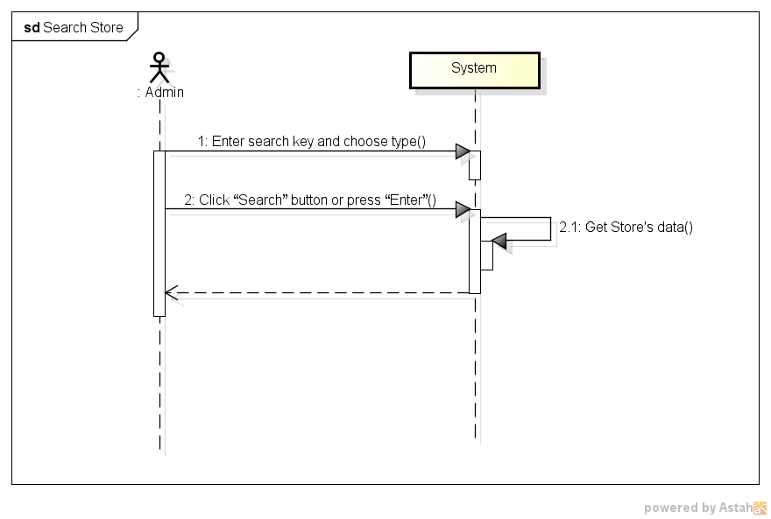

*Figure 11: Sequence Diagram for Search Store Use case*

###### *UC- 107:* *View Store’s list*



*Figure 11: Screen of View Store’s List Use case*

|  |  |  |  |  |
| --- | --- | --- | --- | --- |
| **Use Case ID:** | | UC-107 | | |
| **Use Case Name:** | | View Store’s list | | |
| **Created By:** | | HoangNK | **Last Updated By:** | HoangNK |
| **Date Created:** | | 19/09/2015 | **Date Last updated:** | 19/09/2015 |
| **Actor:** | | Admin | | |
| **Description:** | | Admin views all Store in a table with basic information (address, name, payment,..), so after that, Admin can choose a Store to send message, edit and block or unblock | | |
| **Triggering Event:** | | Admin wants to view all of Store | | |
| **Preconditions:** | | Admin logged in to system | | |
| **Post conditions:** | | List of store is displayed to screen | | |
| **Priority:** | | High | | |
| **Frequency of Use:** | | Always | | |
| **Main flow** | | | | |
| Step | Actor | Action | | |
|  | Admin | Click “Store” button in left navigate bar | | |
|  | System | Display “Store” menu in left navigate bar includes: Accept Store, Store’s List, Confirm Payment and Transaction History | | |
|  | Admin | Click “Store’s list” button | | |
|  | System | Get Store’s data then display “Store’s List” screen includes:   * Search textbox and button * Filter drop-downlist * All Store’s basic information with 3 icon buttons: Update, Send Message and Block or Unblock | | |
| **Alternative Flows:** | | N/A | | |
| **Exceptions:** | |  | | |
| EC1 | At step 4, system can’t get data from database because the internet or the database disconnect | | | |
| Step | Actor | Action | | |
| 4.1 | System | Show error message: “Failed to load data” | | |
| **Includes:** | | N/A | | |
| **Special Requirements:** | | N/A | | |
| **Notes and Issues:** | | N/A | | |

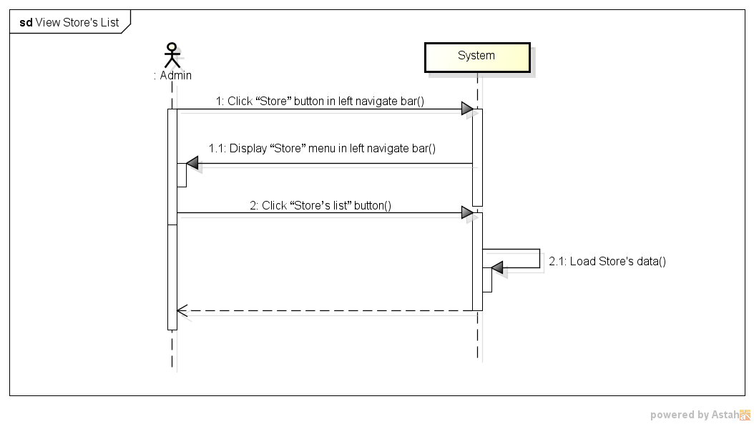

*Figure 11: Sequence Diagram for View Store’s List Use case*

###### *UC- 108:* *Block and Unblock store*

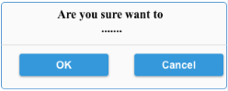

*Figure 11: Screen of Block and Unblock Store Use case*

|  |  |  |  |  |
| --- | --- | --- | --- | --- |
| **Use Case ID:** | | UC-108 | | |
| **Use Case Name:** | | Block and Unblock store | | |
| **Created By:** | | HoangNK | **Last Updated By:** | HoangNK |
| **Date Created:** | | 19/09/2015 | **Date Last updated:** | 24/09/2015 |
| **Actor:** | | Admin | | |
| **Description:** | | Admin bans the store from system if the store has serious breach of contract, so they can’t do any function of system if they were banned. Besides, Admin can unban the Store which is banned to give this Store permission of using Store’s functions | | |
| **Triggering Event:** | | Admin wants to blocks or unblocks store | | |
| **Preconditions:** | | Admin is in view store’s list page ( refer case UC-107 ) | | |
| **Post conditions:** | | Store is blocked or unblocked | | |
| **Priority:** | | Normal | | |
| **Frequency of Use:** | | Sometime | | |
| **Main flow** | | | | |
| Step | Actor | Action | | |
|  | Admin | Click “Block”(“Unblock”) button | | |
|  | System | Display confirm popup includes “Yes” and “No” button | | |
|  | Admin | Click “Yes” button | | |
|  | System | Hide popup and change store’s status of blocking | | |
|  | System | Store is blocked or unblocked | | |
| **Alternative Flows:** | |  | | |
| AT1 | At step 1, if admin click “View store’s details” | | | |
| Step | Actor | Action | | |
| 1 | Admin | Click Store’s name in row (hyperlink) | | |
| 2 | System | Display “View Store’s details” screen | | |
| 3 | Admin | Click “Block” (“Unblock”) button below avatar | | |
| 4 | System | Go to step 2 of main flow and continue | | |
| **Exceptions:** | | | | |
| EC1 | At step 2, Admin click on “No” button | | | |
| Step | Actor | Action | | |
| 2.1 | System | Close popup | | |
|  |  |  | | |
| **Includes:** | | N/A | | |
| **Special Requirements:** | | N/A | | |
| **Notes and Issues:** | | N/A | | |

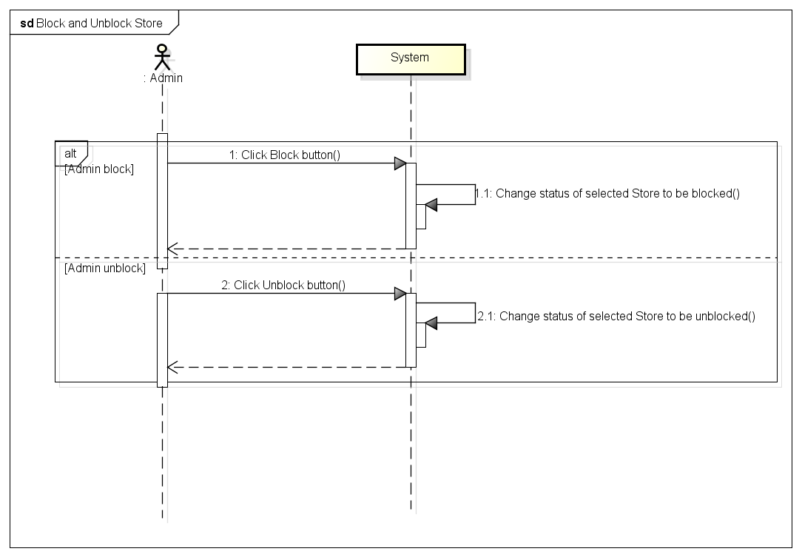

*Figure 11: Sequence Diagram for Block and Unblock Store Use case*

###### *UC- 109:* *View Store’s details*

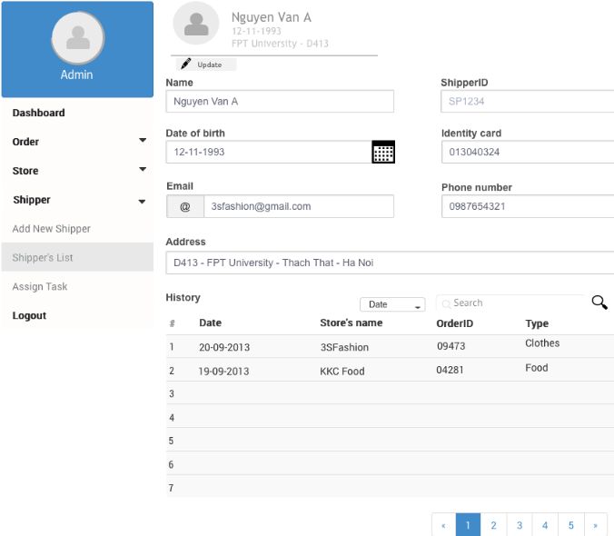

*Figure 11: Screen of View Store’s Details Use case*

|  |  |  |  |  |
| --- | --- | --- | --- | --- |
| **Use Case ID:** | | UC-109 | | |
| **Use Case Name:** | | View Store’s details | | |
| **Created By:** | | HoangNK | **Last Updated By:** | HoangNK |
| **Date Created:** | | 19/09/2015 | **Date Last updated:** | 24/09/2015 |
| **Actor:** | | Admin | | |
| **Description:** | | Admin views all Store’s details (address, name, registered date, phone number, store’s manager, payment, identity card, bank’s account information,…), so after that, Admin can send message, edit and block or unblock this Store | | |
| **Triggering Event:** | | Admin wants to view all information of a Store | | |
| **Preconditions:** | | Admin is in view store’s list page ( refer case UC-107 ) | | |
| **Post conditions:** | | Details of Store are displayed | | |
| **Priority:** | | Normal | | |
| **Frequency of Use:** | | Sometime | | |
| **Main flow** | | | | |
| Step | Actor | Action | | |
|  | Admin | Click Store’s name in row (hyperlink) | | |
|  | System | Load data of selected Store and display “View Store’s details” screen includes store’s details includes: address, name, registered date, phone number, store’s manager, payment, identity card, bank’s account information,… | | |
| **Alternative Flows:** | | N/A | | |
| **Exceptions:** | | N/A | | |
| **Includes:** | | N/A | | |
| **Special Requirements:** | | N/A | | |
| **Notes and Issues:** | | N/A | | |

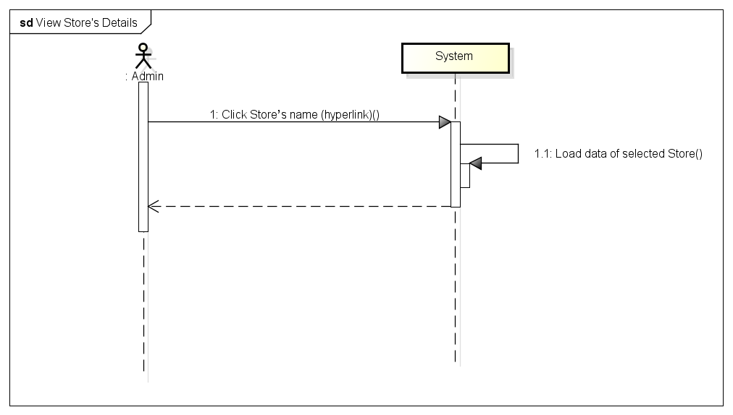

*Figure 11: Sequence Diagram for View Store’s Details Use case*

###### *UC- 110:* *Send message to Store*

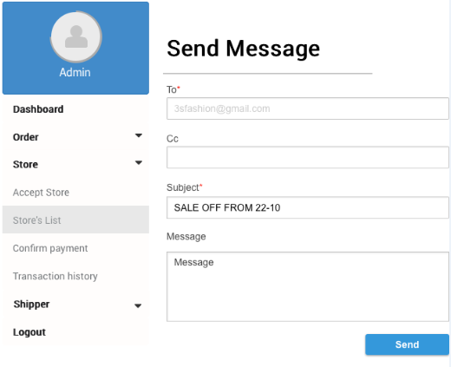

*Figure 11: Screen of Send Message to Store Use case*

|  |  |  |  |  |
| --- | --- | --- | --- | --- |
| **Use Case ID:** | | UC-110 | | |
| **Use Case Name:** | | Send message to Store | | |
| **Created By:** | | HoangNK | **Last Updated By:** | HoangNK |
| **Date Created:** | | 19/09/2015 | **Date Last updated:** | 19/09/2015 |
| **Actor:** | | Admin | | |
| **Description:** | | Admin create a message with Store’s name, subject and content to send to a Store or a lot of Stores (by entering store’s name to Cc textbox) in order to notify the Store’s about news, changes,… | | |
| **Triggering Event:** | | Admin wants to send message to the Store | | |
| **Preconditions:** | | Admin is in view store’s list page ( refer case UC-107 ) | | |
| **Post conditions:** | | A message is sent to the Store | | |
| **Priority:** | | Normal | | |
| **Frequency of Use:** | | Sometime | | |
| **Main flow** | | | | |
| Step | Actor | Action | | |
|  | Admin | Click “Send message” button | | |
|  | System | Display “Send message” screen with send message form includes: store’s name and cc, subject and content | | |
|  | Admin | Fill information in textbox | | |
|  | Admin | Click “Send” button | | |
|  | System | Validate input | | |
|  | System | Send this message to store and show the result of sending to Admin by message: ‘The message has been sent” | | |
| **Alternative Flows:** | |  | | |
| AT1 | At step 1, if admin click “View store’s details” | | | |
| Step | Actor | Action | | |
| 1 | Admin | Click Store’s name in row (hyperlink) | | |
| 2 | System | Display “View Store’s details” screen | | |
| 3 | Admin | Click “Send message” button below avatar | | |
| 4 | System | Go to step 2 of main flow and continue | | |
| **Exceptions:** | | | | |
| EC1 | At step 5, if admin doesn’t type anything in Subject textbox or Content textbox | | | |
| Step | Actor | Action | | |
| 5.1 | System | Notify by error message in screen “*is require” | | |
| EC2 | At step 6, if message can’t send to Store | | | |
| Step | Actor | Action | | |
| 5.1 | System | Notify by error message in screen “Can’t send to Store, please try again!!” | | |
| **Includes:** | | N/A | | |
| **Special Requirements:** | | * Message content must be longer than 20 characters * The field with ‘*’ can’t be blank | | |
| **Notes and Issues:** | | N/A | | |

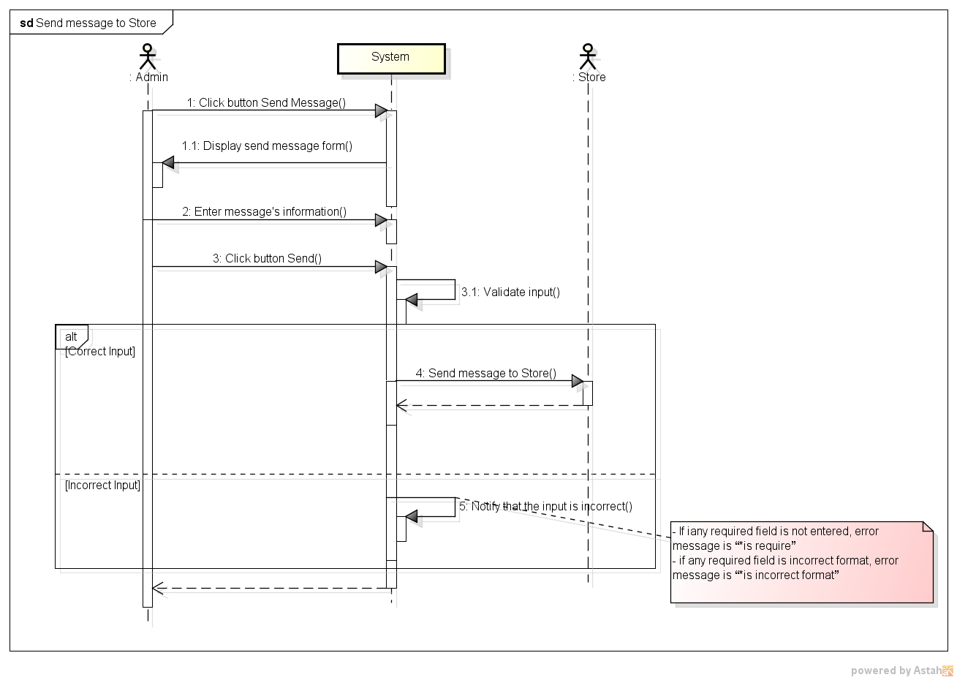

*Figure 11: Sequence Diagram for Send Message to Store Use case*

###### *UC- 111:* *Confirm Store’s payment*

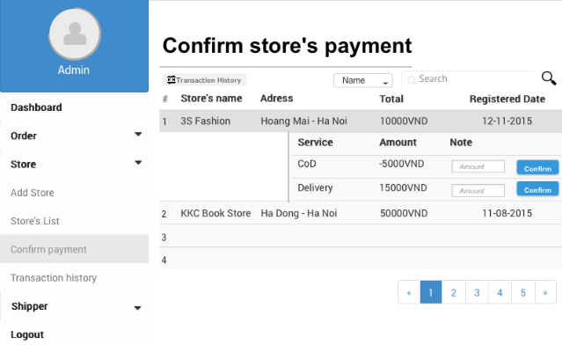

*Figure 11: Screen of Confirm Store’s Payment Use case*

2

|  |  |  |  |  |
| --- | --- | --- | --- | --- |
| **Use Case ID:** | | UC-111 | | |
| **Use Case Name:** | | Confirm Store’s payment | | |
| **Created By:** | | HoangNK | **Last Updated By:** | HoangNK |
| **Date Created:** | | 19/09/2015 | **Date Last updated:** | 24/09/2015 |
| **Actor:** | | Admin | | |
| **Description:** | | After receiving and sending money to the Store, admin updates Store’s payment by confirming amount of money of transactions | | |
| **Triggering Event:** | | Admin wants to confirms the store’s payment | | |
| **Preconditions:** | | Admin logged in to system | | |
| **Post conditions:** | | Payment of this store is updated in database | | |
| **Priority:** | | High | | |
| **Frequency of Use:** | | Always | | |
| **Main flow** | | | | |
| Step | Actor | Action | | |
|  | Admin | Click “Store” button in left navigate bar | | |
|  | System | Display “Store” menu in left navigate bar includes: Accept Store, Store’s List, Confirm Payment and Transaction History | | |
|  | Admin | Click “Confirm store’s payment” button | | |
|  | System | Display “Confirm store’s payment” screen includes:   * Search textbox and button * Filter drop-downlist * Store’s basic information, total payment in each row of a table * List of total payment of delivery service and cash on delivery service, an amount textbox and Confirm button when Admin click Store’s name(hyperlink) | | |
|  | Admin | Enter payment in “Payment” textbox | | |
|  | Admin | Click “Confirm” button | | |
|  | System | Give confirm by displaying confirm popup includes “Yes” and “No” button | | |
|  | Admin | Click “Yes” button | | |
|  | System | Update payment of this store to database | | |
| **Alternative Flows:** | |  | | |
| AT1 | At step 3, if admin click “Store’s list” button | | | |
| Step | Actor | Action | | |
| 3 | Admin | Click “Store’s list” button | | |
| 4 | System | Display “View Store’s details” screen | | |
| 5 | System | Display “Store’s List” screen | | |
| 6 | Admin | Click Store’s name in row (hyperlink) | | |
| 7 | System | Display “View Store’s details” screen includes store’s details | | |
| 8 | Admin | Click “Confirm store’s payment” button | | |
| 9 | System | Go to step 4 of main flow | | |
| **Exceptions:** | | N/A | | |
| **Includes:** | | N/A | | |
| **Special Requirements:** | | * When Admin clicks Store’s name (hyperlink), some rows will be displayed below with incomplete transaction * If the payment is negative, this is payment that the system needs to pay for the Store * If the payment is positive, this is payment that the Store needs to pay for the system * Default value of amount textbox is 0 * The value of amount textbox is only number and absolute value must be less than amount of payment | | |
| **Notes and Issues:** | | N/A | | |

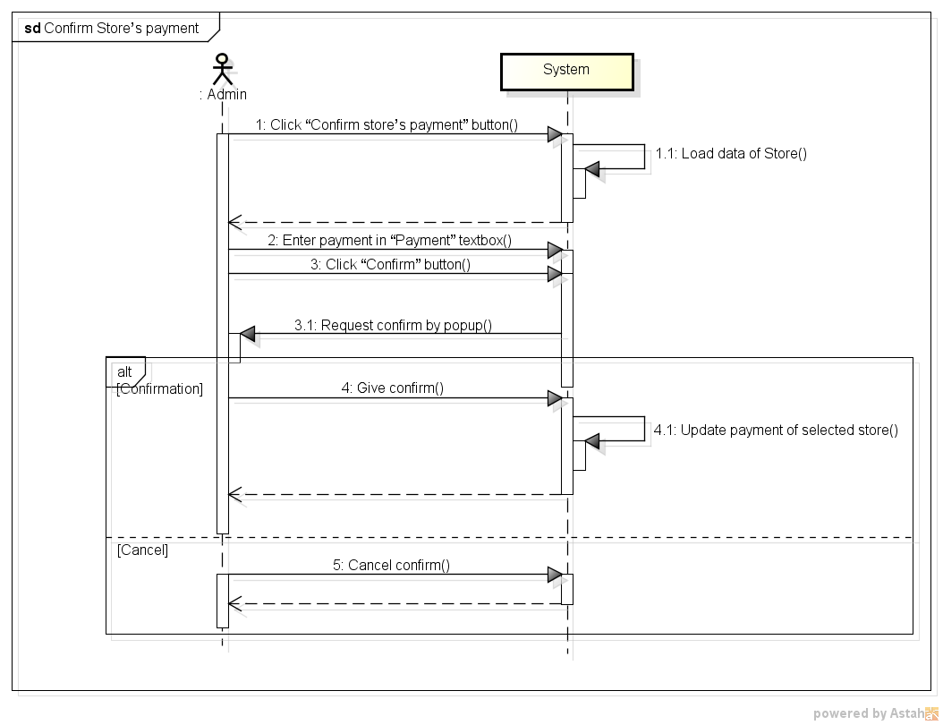

*Figure 11: Sequence Diagram for Confirm Store’s Payment Use case*

###### *UC- 112:* *View* transaction *history of Store*

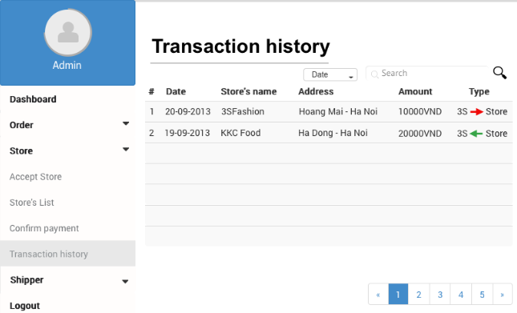

*Figure 11: Screen of View Transaction History of Store Use case*

|  |  |  |  |  |
| --- | --- | --- | --- | --- |
| **Use Case ID:** | | UC-112 | | |
| **Use Case Name:** | | View transaction history of Store | | |
| **Created By:** | | HoangNK | **Last Updated By:** | HoangNK |
| **Date Created:** | | 19/09/2015 | **Date Last updated:** | 19/09/2015 |
| **Actor:** | | Admin | | |
| **Description:** | | Admin wants the system to list all Store’s transaction with basic information (store’s name, address, amount of money, type,..) | | |
| **Triggering Event:** | | Admin wants to view transaction history of Stores | | |
| **Preconditions:** | | Admin logged in to system | | |
| **Post conditions:** | | List of transaction history of Store is displayed | | |
| **Priority:** | | Normal | | |
| **Frequency of Use:** | | Sometime | | |
| **Main flow** | | | | |
| Step | Actor | Action | | |
|  | Admin | Click “Store” button in left navigate bar | | |
|  | System | Display “Store” menu in left navigate bar includes: Accept Store, Store’s List, Confirm Payment and Transaction History | | |
|  | Admin | Click “Transaction history” button | | |
|  | System | Load data of transaction and display “Transaction history” screen includes   * Search textbox and button * Filter drop-downlist * Basic information of transaction in a table | | |
| **Alternative Flows:** | | | | |
| AT1 | At step 3, if admin click “Store’s list” button | | | |
| Step | Actor | Action | | |
| 3 | Admin | Click “Store’s list” button | | |
| 4 | System | Display “View Store’s details” screen | | |
| 5 | System | Display “Store’s List” screen | | |
| 6 | Admin | Click Store’s name in row (hyperlink) | | |
| 7 | System | Display “View Store’s details” screen includes store’s details | | |
| 8 | Admin | Click “Transaction history” button | | |
| 9 | System | Go to step 4 of main flow | | |
| **Exceptions:** | | N/A | | |
| **Includes:** | | N/A | | |
| **Special Requirements:** | | N/A | | |
| **Notes and Issues:** | | N/A | | |

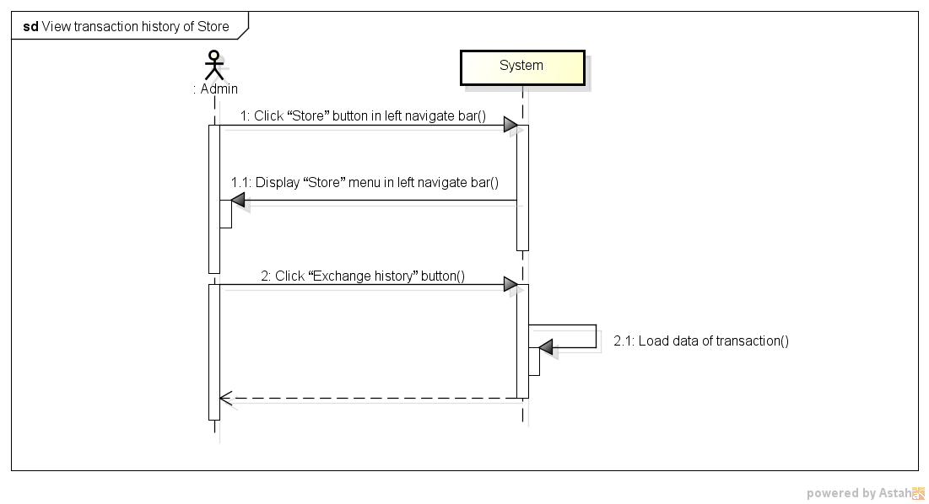

*Figure 11: Sequence Diagram for View Transaction history of Store Use case*

###### *UC- 113:* *Add Shipper*

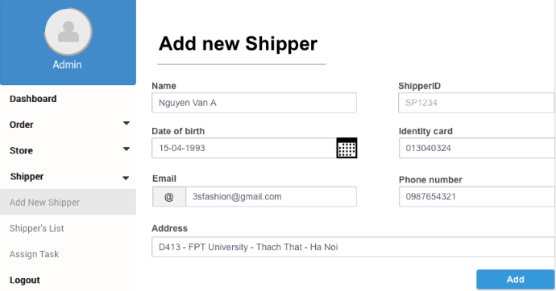

*Figure 11: Screen of Add Shipper Use case*

|  |  |  |  |  |
| --- | --- | --- | --- | --- |
| **Use Case ID:** | | UC-113 | | |
| **Use Case Name:** | | Add New Shipper | | |
| **Created By:** | | HoangNK | **Last Updated By:** | HoangNK |
| **Date Created:** | | 19/09/2015 | **Date Last updated:** | 19/09/2015 |
| **Actor:** | | Admin | | |
| **Description:** | | Admin create new account to new Shipper with basic information of Shipper: name, date of birth, email, phone number, identity card, address,… | | |
| **Triggering Event:** | | Admin wants to adds a new Shipper to system | | |
| **Preconditions:** | | Admin logged in to system | | |
| **Post conditions:** | | New Shipper and new account for this Shipper are added to database | | |
| **Priority:** | | High | | |
| **Frequency of Use:** | | Often | | |
| **Main flow** | | | | |
| Step | Actor | Action | | |
|  | Admin | Click “Shipper” button in left navigate bar | | |
|  | System | Display “Shipper” menu in left navigate bar includes Add New Shipper, Shipper’s List and Assign Task | | |
|  | Admin | Click “Add new Shipper” button | | |
|  | System | Display “Add new Shipper” form includes textbox of : name, date of birth, email, phone number, identity card, address | | |
|  | Admin | Enter new Shipper’s information into fields | | |
|  | Admin | Click “Add” button | | |
|  | System | Validate input | | |
|  | System | Add new Shipper and new account of this Shipper to database then redirect to “Shipper’s List” page | | |
| **Alternative Flows:** | | N/A | | |
| **Exceptions:** | | | | |
| EC1 | At step 7, if any required field is not entered | | | |
| Step | Actor | Action | | |
| 7.1 | System | Notify in screen by error message “*is require” | | |
| EC2 | At step 7, if any required field is incorrect format | | | |
| Step | Actor | Action | | |
| 7.1 | System | Notify in screen by error message “*is incorrect format” | | |
| EC3 | At step 7, if identity card or email has been already existed | | | |
| Step | Actor | Action | | |
| 7.1 | System | Notify in screen by error message “* has been already existed” | | |
| **Includes:** | | N/A | | |
| **Special Requirements:** | | * ShipperID will be generated automatically by system * Default account and password for new Shipper is shipperID, Shipper can change them by mobile app later * The field with ‘*’ can’t be blank | | |
| **Notes and Issues:** | | N/A | | |

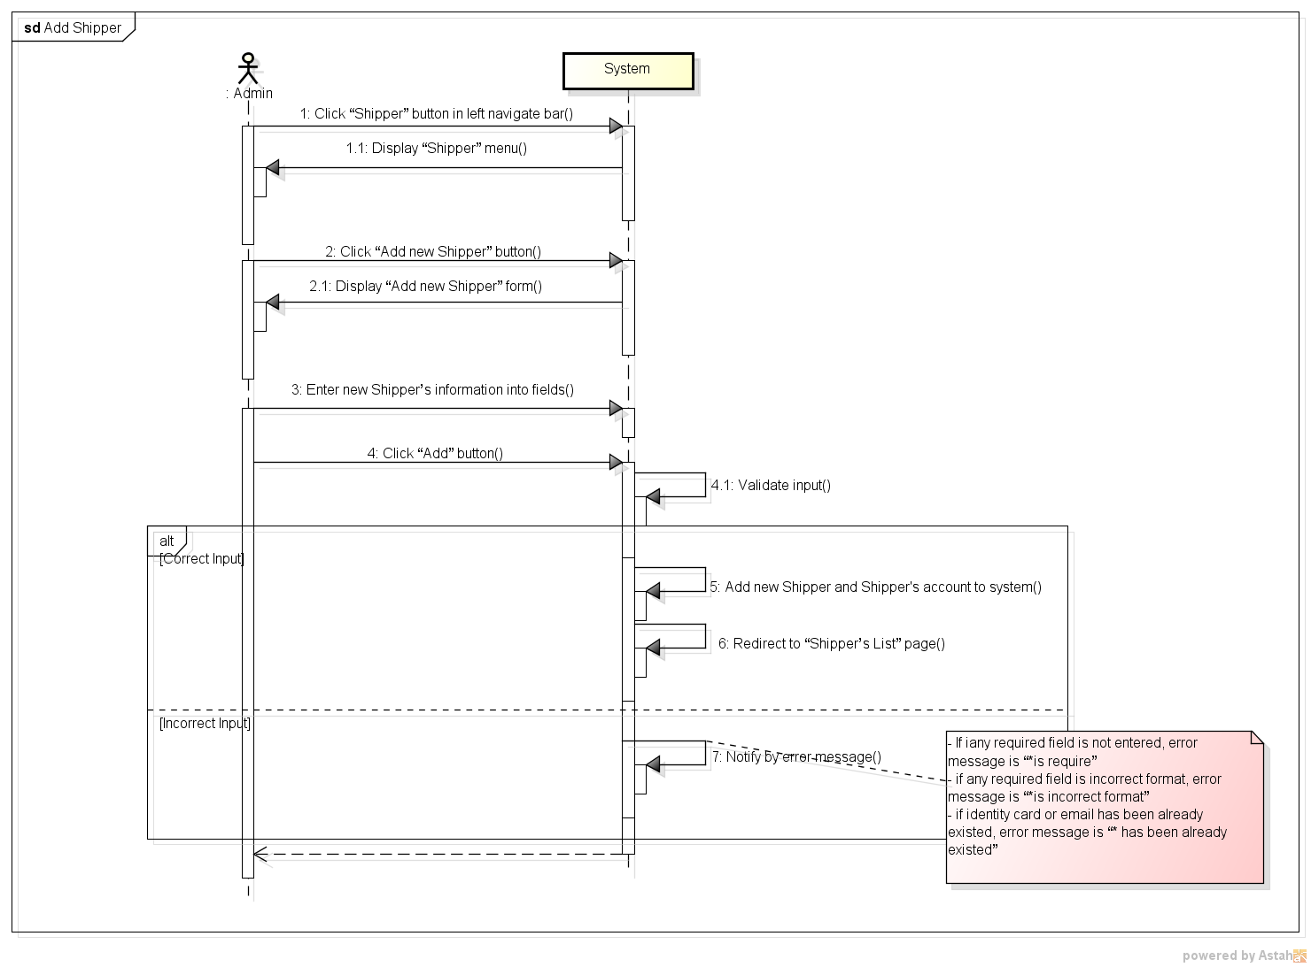

*Figure 11: Sequence Diagram for Add Shipper Use case*

###### *UC- 114:* *View Shipper’s list*

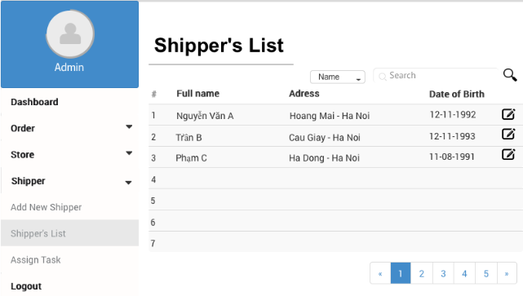

*Figure 11: Screen of View Shipper’s List Use case*

|  |  |  |  |  |
| --- | --- | --- | --- | --- |
| **Use Case ID:** | | UC-114 | | |
| **Use Case Name:** | | View Shipper’s list | | |
| **Created By:** | | HoangNK | **Last Updated By:** | HoangNK |
| **Date Created:** | | 19/09/2015 | **Date Last updated:** | 19/09/2015 |
| **Actor:** | | Admin | | |
| **Description:** | | Admin views all Shipper in a table with basic information (address, name, date of birth,..), so after that, Admin can choose a Shipper to update information | | |
| **Triggering Event:** | | Admin wants to view all Shipper | | |
| **Preconditions:** | | Admin logged in to system | | |
| **Post conditions:** | | List of shipper is displayed | | |
| **Priority:** | | High | | |
| **Frequency of Use:** | | Always | | |
| **Main flow** | | | | |
| Step | Actor | Action | | |
|  | Admin | Click “Shipper” button in left navigate bar | | |
|  | System | Display “Shipper” menu in left navigate bar includes Add New Shipper, Shipper’s List and Assign Task | | |
|  | Admin | Click “Shipper’s list” button | | |
|  | System | Load Shipper's data and display “Shipper’s List” screen includes:   * Search textbox and button * Filter drop-downlist * All Shipper’s basic information with Update icon buttons | | |
| **Alternative Flows:** | | **N/A** | | |
| **Exceptions:** | | **N/A** | | |
| **Includes:** | | N/A | | |
| **Special Requirements:** | | * The default Shipper’s list is ordered by Name | | |
| **Notes and Issues:** | | N/A | | |

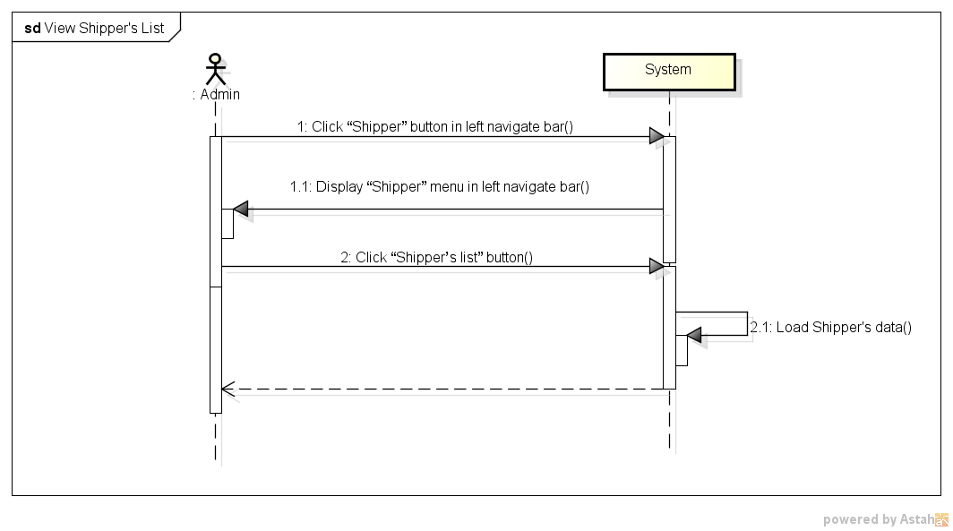

*Figure 11: Sequence Diagram for View Shipper List Use case*

###### *UC- 115:* *View Order’s list*

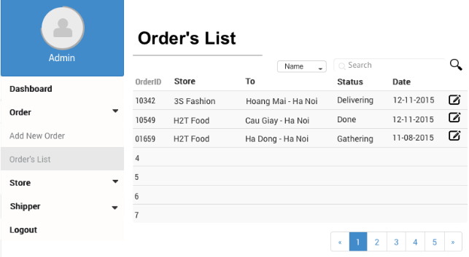

*Figure 11: Screen of View Order’s List Use case*

|  |  |  |  |  |
| --- | --- | --- | --- | --- |
| **Use Case ID:** | | UC-115 | | |
| **Use Case Name:** | | View Order’s list | | |
| **Created By:** | | HoangNK | **Last Updated By:** | HoangNK |
| **Date Created:** | | 19/09/2015 | **Date Last updated:** | 19/09/2015 |
| **Actor:** | | Admin | | |
| **Description:** | | Admin views all Order in a table with basic information (orderID, store’s name, recipient’s address, status, date,..), so after that, Admin can choose an Order to update information | | |
| **Triggering Event:** | | Admin wants to view all Orders | | |
| **Preconditions:** | | Admin logged in to system | | |
| **Post conditions:** | | List of order is displayed | | |
| **Priority:** | | High | | |
| **Frequency of Use:** | | Always | | |
| **Main flow** | | | | |
| Step | Actor | Action | | |
|  | Admin | Click “Order” button in left navigate bar | | |
|  | System | Display “Order” menu in left navigate bar includes Add Add New Order, Order’s List | | |
|  | Admin | Click “Order’s list” button | | |
|  | System | Load Order's data and display “Order’s List” screen includes   * Search textbox and button * Filter drop-downlist * All Order’s basic information with Update icon buttons | | |
| **Alternative Flows:** | | **N/A** | | |
| **Exceptions:** | | **N/A** | | |
| **Includes:** | | N/A | | |
| **Special Requirements:** | | * The default Order’s list is ordered by Date | | |
| **Notes and Issues:** | | N/A | | |

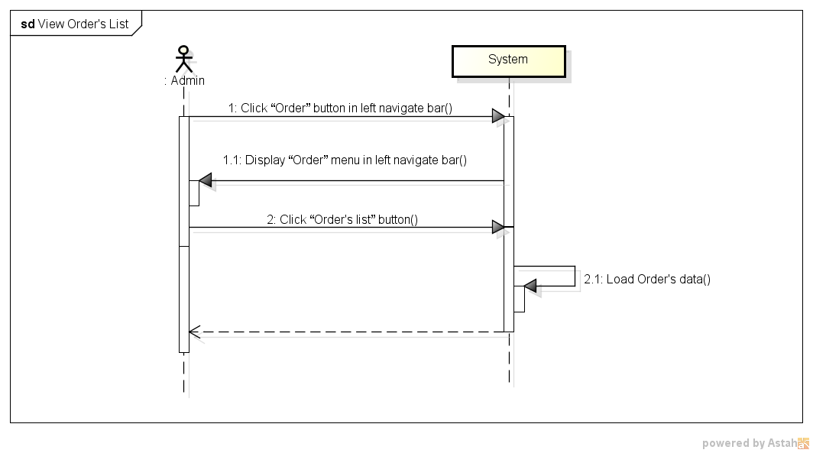

*Figure 11: Sequence Diagram for View Order’s List Use case*

###### *UC- 117:* *Search Shipper*



*Figure 11: Screen of Search Shipper Use case*

|  |  |  |  |  |
| --- | --- | --- | --- | --- |
| **Use Case ID:** | | UC-116 | | |
| **Use Case Name:** | | Search Shipper | | |
| **Created By:** | | HoangNK | **Last Updated By:** | HoangNK |
| **Date Created:** | | 19/09/2015 | **Date Last updated:** | 19/09/2015 |
| **Actor:** | | Admin | | |
| **Description:** | | Admin wants the system to list all Shipper related to a specific keyword and type, after that, Admin can choose a Shipper to update information | | |
| **Triggering Event:** | | Admin wants to search Shipper | | |
| **Preconditions:** | | Admin is in view shipper’s list page ( refer case UC-114 ) | | |
| **Post conditions:** | | Display Shipper as result of search | | |
| **Priority:** | | High | | |
| **Frequency of Use:** | | Always | | |
| **Main flow** | | | | |
| Step | Actor | Action | | |
|  | Admin | Choose type of Shipper: Name, Address or ID | | |
|  | Admin | Enter text to “Search” text box | | |
|  | Admin | Click “Search” button or press “Enter” | | |
|  | System | Get Shipper's data and display result on screen includes:   * Search textbox and button * Filter drop-downlist * Related Shipper’s basic information with Update icon button | | |
| **Alternative Flows:** | | N/A | | |
| **Exceptions:** | | N/A | | |
| EC1 | At step 3, Admin doesn’t choose any type | | | |
| Step | Actor | Action | | |
| 3.1 | System | Set Name is default type | | |
| **Includes:** | | N/A | | |
| **Special Requirements:** | | * Result of search is case insensitive * Types of search are Name, Address and ID | | |
| **Notes and Issues:** | | N/A | | |

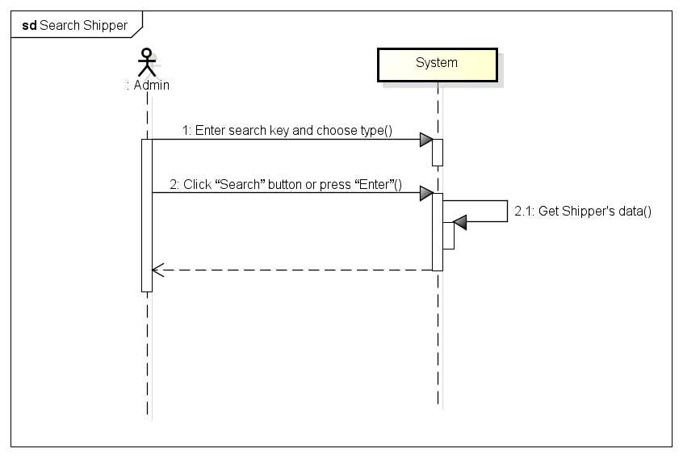

*Figure 11: Sequence Diagram for Search Shipper Use case*

###### *UC- 117:* *Search Order*



*Figure 11: Screen of Search Order Use case*

|  |  |  |  |  |
| --- | --- | --- | --- | --- |
| **Use Case ID:** | | UC-117 | | |
| **Use Case Name:** | | Search Order | | |
| **Created By:** | | HoangNK | **Last Updated By:** | HoangNK |
| **Date Created:** | | 19/09/2015 | **Date Last updated:** | 19/09/2015 |
| **Actor:** | | Admin | | |
| **Description:** | | Admin wants the system to list all Order related to a specific keyword and type, after that, Admin can choose an Order to update information | | |
| **Triggering Event:** | | Admin wants to search Order | | |
| **Preconditions:** | | Admin is in view order’s list page ( refer case UC-115 ) | | |
| **Post conditions:** | | Display Order as result of search | | |
| **Priority:** | | High | | |
| **Frequency of Use:** | | Always | | |
| **Main flow** | | | | |
| Step | Actor | Action | | |
|  | Admin | Choose type of Order: Type, Address, Date, Store’s name or Shipper’s name | | |
|  | Admin | Enter text to “Order” text box | | |
|  | Admin | Click “Order” button or press “Enter” | | |
|  | System | Get Shipper's data and display result on screen includes   * Search textbox and button * Filter drop-downlist * Related Order’s basic information with Update icon button | | |
| **Alternative Flows:** | | N/A | | |
| **Exceptions:** | | N/A | | |
| EC1 | At step 3, Admin doesn’t choose any type | | | |
| Step | Actor | Action | | |
| 3.1 | System | Set All is default type | | |
| **Includes:** | | N/A | | |
| **Special Requirements:** | | * Result of search is case insensitive * Types of search are Name, Address and ID | | |
| **Notes and Issues:** | | N/A | | |

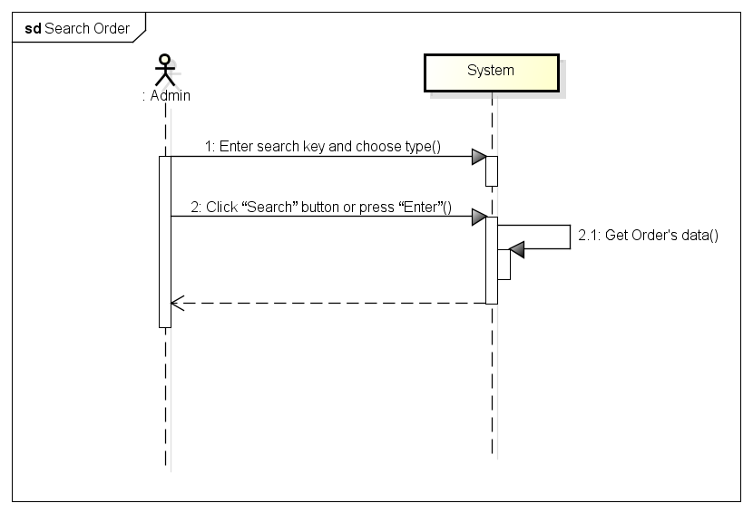

*Figure 11: Sequence Diagram for Search Order Use case*

###### *UC- 118:* *View Shipper’s profile*

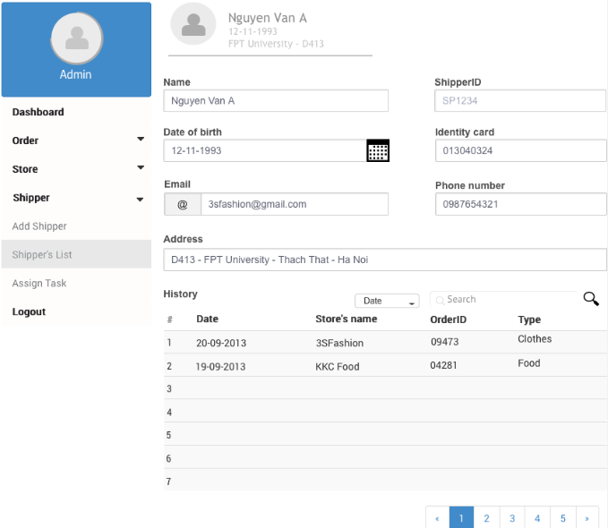

|  |  |  |  |  |
| --- | --- | --- | --- | --- |
| **Use Case ID:** | | UC-118 | | |
| **Use Case Name:** | | View Shipper’s profile | | |
| **Created By:** | | HoangNK | **Last Updated By:** | HoangNK |
| **Date Created:** | | 19/09/2015 | **Date Last updated:** | 24/09/2015 |
| **Actor:** | | Admin | | |
| **Description:** | | Admin views all Shipper’s details (address, name, date of birth, phone number, email, address, shipping history…), so after that, Admin can update Shipper information | | |
| **Triggering Event:** | | Admin wants to view profile of a Shipper | | |
| **Preconditions:** | | Admin is in view shipper’s list page ( refer case UC-114 ) | | |
| **Post conditions:** | | Profile of Shipper is displayed | | |
| **Priority:** | | Normal | | |
| **Frequency of Use:** | | Sometime | | |
| **Main flow** | | | | |
| Step | Actor | Action | | |
|  | Admin | Click Shipper’s name in row (hyperlink) | | |
|  | System | Load data of selected Shipper and display “View Shipper’s profile” screen includes information of address, name, date of birth, phone number, email, address, shipping history… and Update button | | |
| **Alternative Flows:** | | N/A | | |
| **Exceptions:** | | N/A | | |
| **Includes:** | | N/A | | |
| **Special Requirements:** | | N/A | | |
| **Notes and Issues:** | | N/A | | |

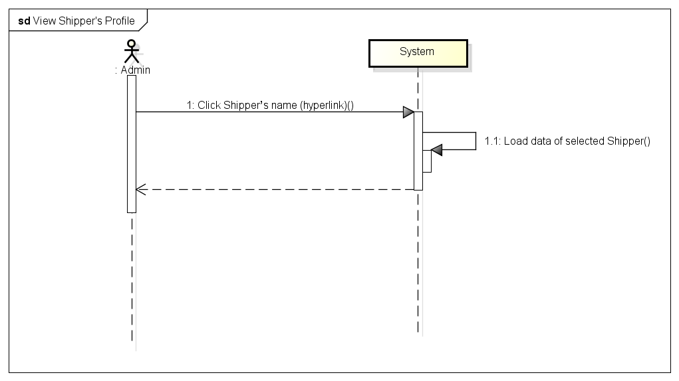

*Figure 11: Sequence Diagram of View Shipper’s Profile Use case*

###### *UC- 119:* *View Order’s details*

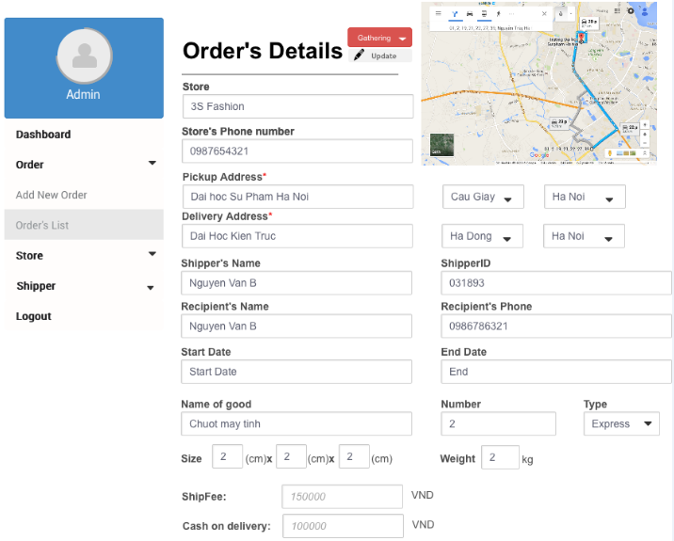

|  |  |  |  |  |
| --- | --- | --- | --- | --- |
| **Use Case ID:** | | UC-119 | | |
| **Use Case Name:** | | View Order’s details | | |
| **Created By:** | | HoangNK | **Last Updated By:** | HoangNK |
| **Date Created:** | | 19/09/2015 | **Date Last updated:** | 19/09/2015 |
| **Actor:** | | Admin | | |
| **Description:** | | Admin views all Order’s details (status of the order , store’s name, pickup and delivery address and date, shipper’s name, recipient’s name, recipient’s phone, goods, type of delivery, size, fee, cash on delivery, …), so after that, Admin can update Shipper information | | |
| **Triggering Event:** | | Admin wants to view all information of the Order | | |
| **Preconditions:** | | Admin is in view shipper’s list page ( refer case UC-115) | | |
| **Post conditions:** | | Details of Order is displayed | | |
| **Priority:** | | Normal | | |
| **Frequency of Use:** | | Sometime | | |
| **Main flow** | | | | |
| Step | Actor | Action | | |
|  | Admin | Click Order’s name in row (hyperlink) | | |
|  | System | Load data of selected Order and display to “View Order’s details” screen includes information of status of the order , store’s name, pickup and delivery address and date, shipper’s name, recipient’s name, recipient’s phone, goods, type of delivery, size, fee, cash on delivery, … | | |
| **Alternative Flows:** | | N/A | | |
| **Exceptions:** | | N/A | | |
| **Includes:** | | N/A | | |
| **Special Requirements:** | | N/A | | |
| **Notes and Issues:** | | N/A | | |

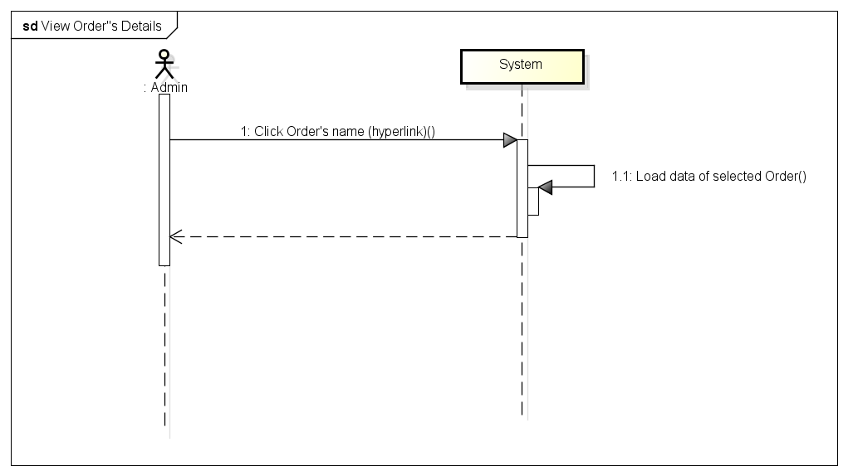

*Figure 11: Sequence Diagram for View Order Details Use case*

###### *UC- 120:* *Update Shipper*

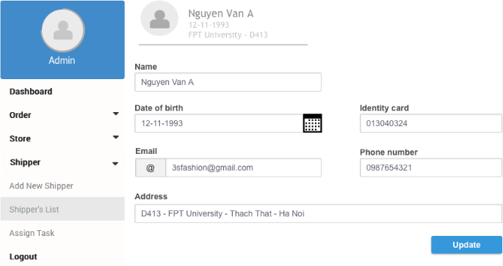

|  |  |  |  |  |
| --- | --- | --- | --- | --- |
| **Use Case ID:** | | UC-120 | | |
| **Use Case Name:** | | Update Shipper | | |
| **Created By:** | | HoangNK | **Last Updated By:** | HoangNK |
| **Date Created:** | | 19/09/2015 | **Date Last updated:** | 19/09/2015 |
| **Actor:** | | Admin | | |
| **Description:** | | Admin modifies an existed Shipper with related information about name, date of birth, identity card, email, phone number, address,.. | | |
| **Triggering Event:** | | Admin wants to update Shipper’s information | | |
| **Preconditions:** | | Admin is in view shipper’s list page ( refer case UC-114) | | |
| **Post conditions:** | | Information of Shipper is updated in database | | |
| **Priority:** | | Normal | | |
| **Frequency of Use:** | | Sometime | | |
| **Main flow** | | | | |
| Step | Actor | Action | | |
|  | Admin | Click icon “Update” button | | |
|  | System | Get data of selected Shipper and display “Update Shipper” screen includes textbox of information about name, date of birth, identity card, email, phone number, address,.. | | |
|  | Admin | Enter new information to fields then click “Update” button | | |
|  | System | Validate input | | |
|  | System | Update Shipper’s new information to database then redirect to Shipper’s profile page | | |
| **Alternative Flows:** | |  | | |
| AT1 | At step 1, if admin click “View Shipper’s profile” | | | |
| Step | Actor | Action | | |
| 1 | Admin | Click Shipper’s name in row (hyperlink) | | |
| 2 | System | Display “View Shipper’s profile” screen | | |
| 3 | Admin | Click “Update” button below avatar | | |
| 4 | System | Go to step 6 of main flow and continue | | |
| **Exceptions:** | | | | |
| EC1 | At step 4, if any required field is not entered | | | |
| Step | Actor | Action | | |
| 4.1 | System | Notify by error message in screen “* is required” | | |
| EC2 | At step 4, if any entered field is incorrect format | | | |
| Step | Actor | Action | | |
| 4.1 | System | Notify by error message in screen “* is incorrect format” | | |
| **Includes:** | | N/A | | |
| **Special Requirements:** | | * The field with ‘*’ can’t be blank | | |
| **Notes and Issues:** | | N/A | | |

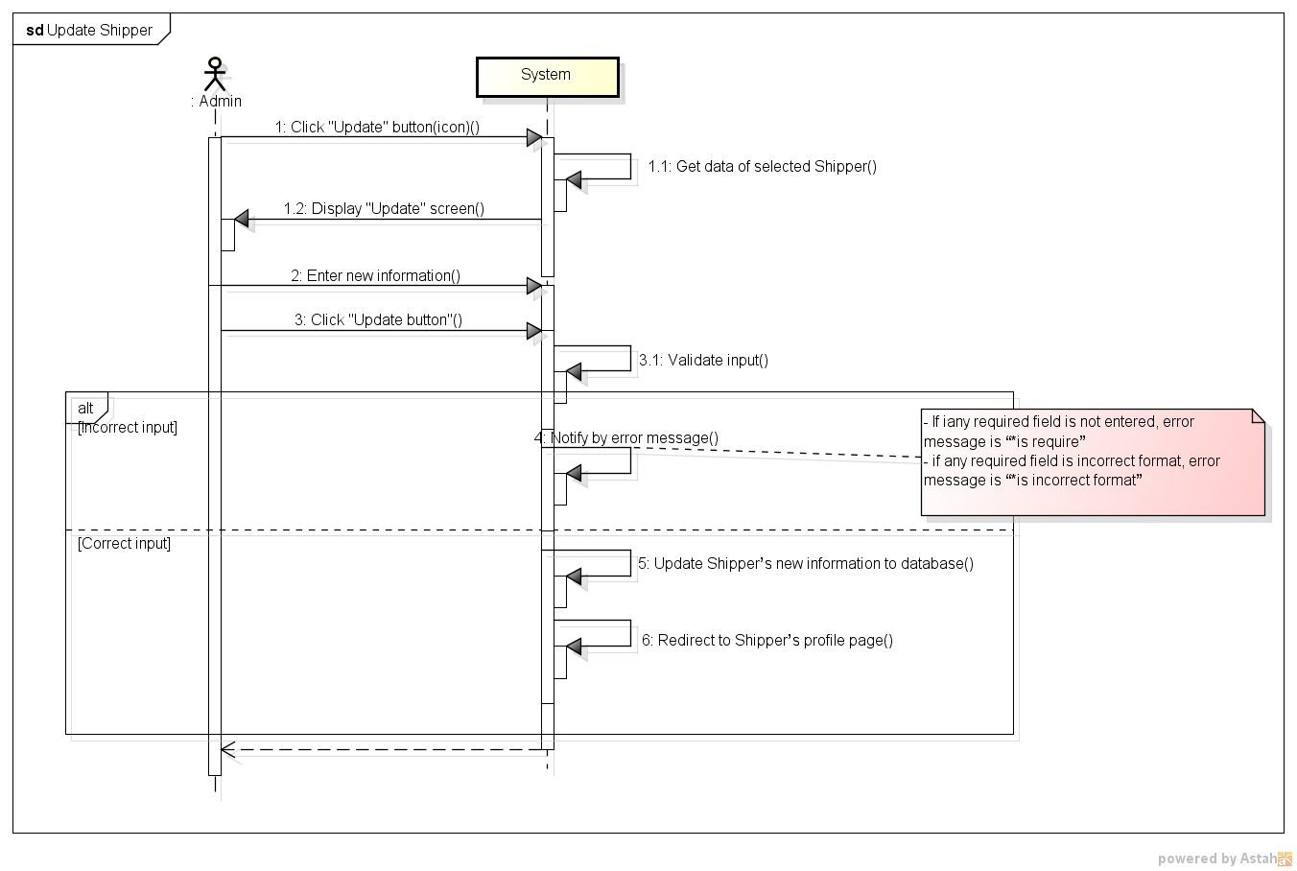

*Figure 11: Sequence Diagram for Update Shipper Use case*

###### *UC- 121:* *Update Order*

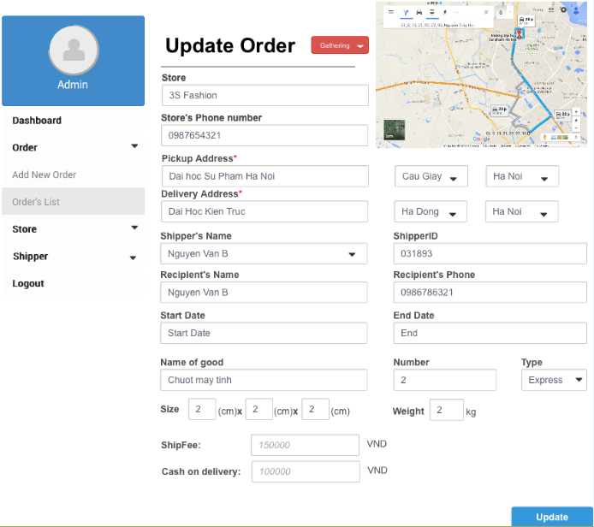

|  |  |  |  |  |
| --- | --- | --- | --- | --- |
| **Use Case ID:** | | UC-121 | | |
| **Use Case Name:** | | Update Order | | |
| **Created By:** | | HoangNK | **Last Updated By:** | HoangNK |
| **Date Created:** | | 19/09/2015 | **Date Last updated:** | 19/09/2015 |
| **Actor:** | | Admin | | |
| **Description:** | | Admin modifies an existed Order with related information about status of the order, store’s name, pickup and delivery address and date, shipper’s name, recipient’s name, recipient’s phone, goods, type of delivery, size, fee, cash on delivery, … | | |
| **Triggering Event:** | | Admin wants to update Order’s information | | |
| **Preconditions:** | | Admin is in view shipper’s list page ( refer case UC-115) | | |
| **Post conditions:** | | Information of Order is updated | | |
| **Priority:** | | Normal | | |
| **Frequency of Use:** | | Sometime | | |
| **Main flow** | | | | |
| Step | Actor | Action | | |
|  | Admin | Click “Update” button | | |
|  | System | Get data of selected Order and display “Update Order” screen includes textbox of status of the order, store’s name, pickup and delivery address and date, shipper’s name, recipient’s name, recipient’s phone, goods, type of delivery, size, fee, cash on delivery, … and Update button | | |
|  | Admin | Enter new information to fields then click “Update” button | | |
|  | System | Validate input | | |
|  | System | Update Order’s new information to database then redirect to Order’s details page | | |
| **Alternative Flows:** | |  | | |
| AT1 | At step 1, if admin click “View Order’s details” | | | |
| Step | Actor | Action | | |
| 1 | Admin | Click Order’s name in row (hyperlink) | | |
| 2 | System | Display “View Order’s details” screen | | |
| 3 | Admin | Click “Update” button below avatar | | |
| 4 | System | Go to step 6 of main flow and continue | | |
| **Exceptions:** | | | | |
| EC1 | At step 4, if any required field is not entered | | | |
| Step | Actor | Action | | |
| 4.1 | System | Notify by error message “* is required” in screen | | |
| EC2 | At step 4, if any entered field is incorrect format | | | |
| Step | Actor | Action | | |
| 4.1 | System | Notify by error message “* is incorrect format” in screen | | |
| **Includes:** | | N/A | | |
| **Special Requirements:** | | * The field with ‘*’ can’t be blank | | |
| **Notes and Issues:** | | N/A | | |

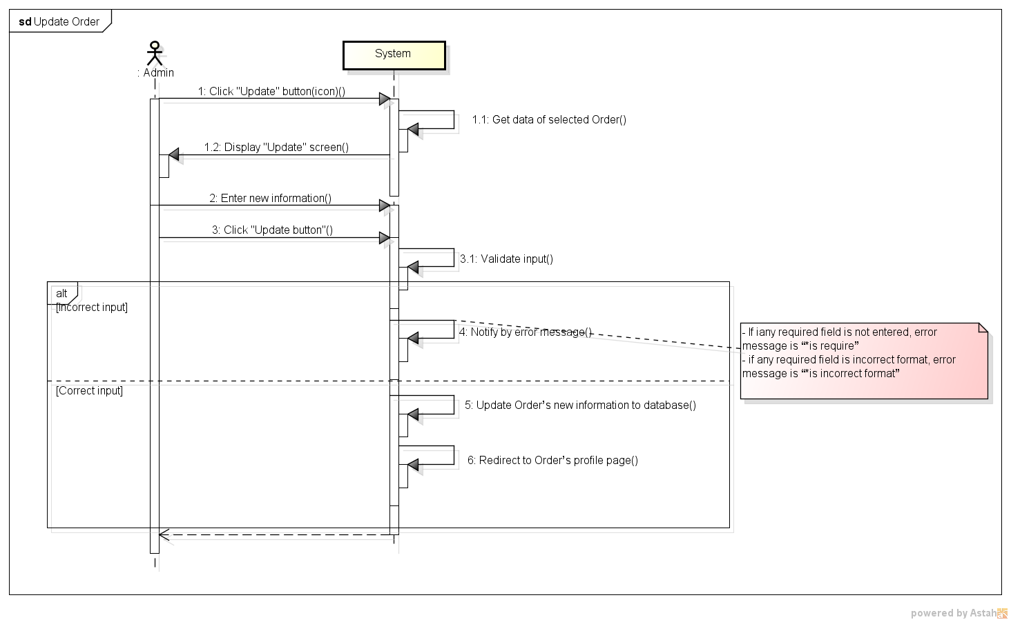

*Figure 11: Sequence Diagram for Update Order Use case*

###### *UC- 123:* Export Bill



|  |  |  |  |  |
| --- | --- | --- | --- | --- |
| **Use Case ID:** | | UC-123 | | |
| **Use Case Name:** | | Export Bill | | |
| **Created By:** | | HoangNK | **Last Updated By:** | HoangNK |
| **Date Created:** | | 19/09/2015 | **Date Last updated:** | 19/09/2015 |
| **Actor:** | | Admin | | |
| **Description:** | | Admin chooses store to export to pdf file to print or send to Store, the content of pdf file contains transaction history of this Store so it can show to store how much money that store needs to pay | | |
| **Triggering Event:** | | Admin wants to export bills to pdf file | | |
| **Preconditions:** | | Admin is in view store’s list page ( refer case UC-107 ) | | |
| **Post conditions:** | | An PDF file is exported | | |
| **Priority:** | | Medium | | |
| **Frequency of Use:** | | Sometime | | |
| **Main flow** | | | | |
| Step | Actor | Action | | |
|  | Admin | Click icon “Export” button | | |
|  | System | Show File Chooser dialog for Admin | | |
|  | Admin | Choose location (directory) for exported file | | |
|  | System | Export these orders to PDF file to location | | |
| **Alternative Flows:** | | N/A | | |
| **Exceptions:** | | | | |
| EC1 | At step 3, if Admin doesn’t choose any folder | | | |
| Step | Actor | Action | | |
| 3.1 | System | Stop exporting file | | |
| **Includes:** | | N/A | | |
| **Special Requirements:** | | * Exported file must be in pdf format * System must display only directory for saving exported file | | |
| **Notes and Issues:** | | N/A | | |

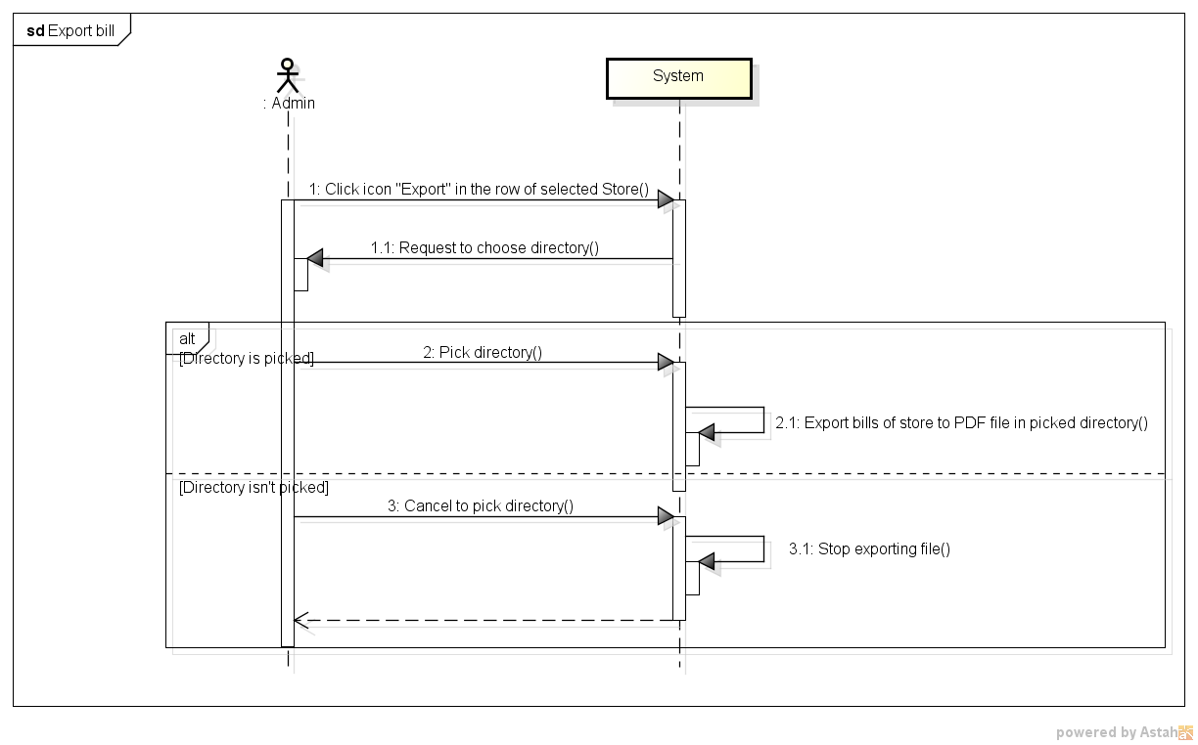

*Figure 11: Sequence Diagram for Export bill Use case*

###### *UC- 124:* *Assign Task*

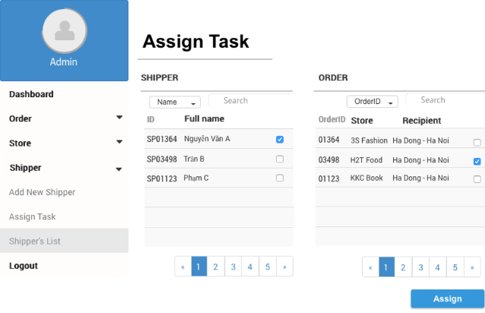

|  |  |  |  |  |
| --- | --- | --- | --- | --- |
| **Use Case ID:** | | UC-124 | | |
| **Use Case Name:** | | Assign Task | | |
| **Created By:** | | HoangNK | **Last Updated By:** | HoangNK |
| **Date Created:** | | 19/09/2015 | **Date Last updated:** | 19/09/2015 |
| **Actor:** | | Admin | | |
| **Description:** | | Admin assigns orders which hasn’t been assign for any Shipper to available Shipper | | |
| **Triggering Event:** | | Admin wants to assign task for Shipper | | |
| **Preconditions:** | | Admin logged in to system | | |
| **Post conditions:** | | Task is assigned for Shipper | | |
| **Priority:** | | High | | |
| **Frequency of Use:** | | Often | | |
| **Main flow** | | | | |
| Step | Actor | Action | | |
|  | Admin | Click “Shipper” button in left navigate bar | | |
|  | System | Display “Shipper” menu in left navigate bar includes Add Shipper, Assign Task, Shipper’s List | | |
|  | Admin | Click “Assign Task” button | | |
|  | System | Get data of Order and Shipper then display “Assign Task” screen includes:   * 2 table of available Shipper and Order with basic information and a checkbox * Search textbox and Filter on each table | | |
|  | Admin | Pick a Shipper in Shipper’s list then pick Order for this Shipper in Order’s list then click “Assign” button | | |
|  | System | Hide picked orders from Order’s list and update Shipper’s information in database | | |
| **Alternative Flows:** | | **N/A** | | |
| **Exceptions:** | | | | |
| EC1 | At step 5, if Admin doesn’t pick any order | | | |
| Step | Actor | Action | | |
| 5.1 | System | Order isn’t active to pick and “Assign” button isn’t active to click | | |
| EC2 | At step 5, if Admin checks a picked order | | | |
| Step | Actor | Action | | |
| 5.2 | System | Order is showed in order's list | | |
| **Includes:** | | N/A | | |
| **Special Requirements:** | | * Available Shippers are displayed in Shipper’s list * Available Orders are displayed in Order’s list | | |
| **Notes and Issues:** | | N/A | | |

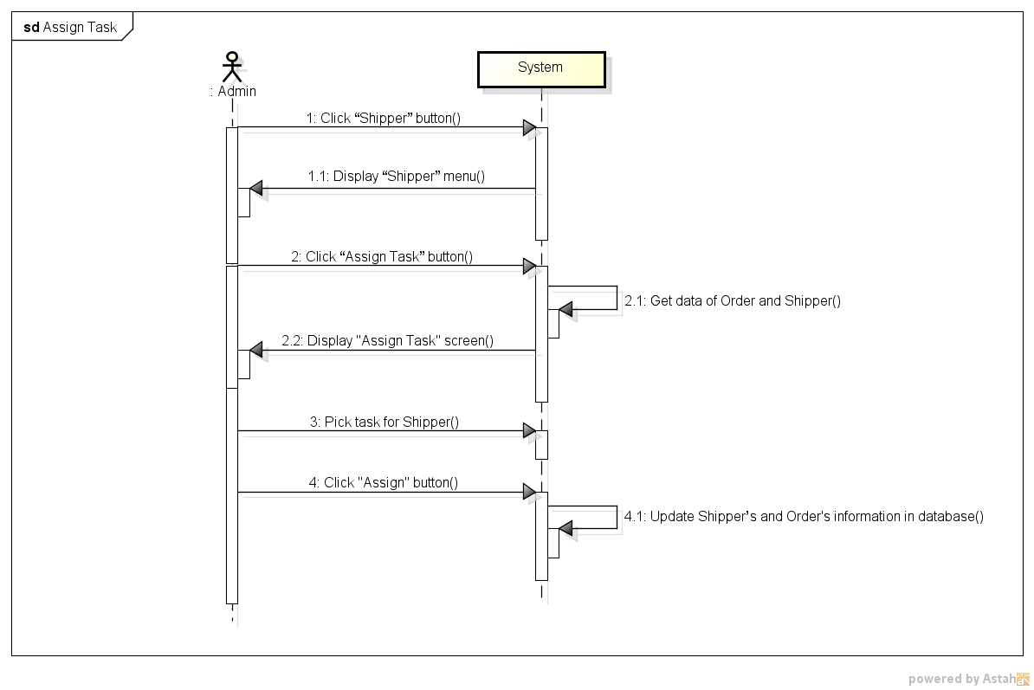

*Figure 11: Sequence Diagram for Assign Task Use case*

###### *UC- 125:* *View Dashboard*

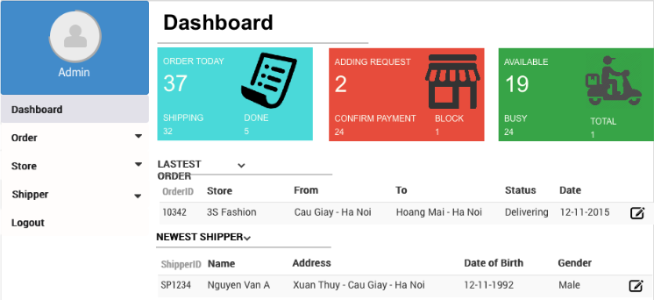

|  |  |  |  |  |
| --- | --- | --- | --- | --- |
| **Use Case ID:** | | UC-125 | | |
| **Use Case Name:** | | View dashboard | | |
| **Created By:** | | HoangNK | **Last Updated By:** | HoangNK |
| **Date Created:** | | 19/09/2015 | **Date Last updated:** | 19/09/2015 |
| **Actor:** | | Admin | | |
| **Description:** | | A view of some statistics about order, shipper, store and other information (latest order, newest shipper,…) is displayed to Admin so Admin has a general view about order, store and shipper | | |
| **Triggering Event:** | | Admin wants to dashboard with the statistics | | |
| **Preconditions:** | | Admin logged in to system | | |
| **Post conditions:** | | Dashboard screen with statistics is displayed | | |
| **Priority:** | | Normal | | |
| **Frequency of Use:** | | Sometime | | |
| **Main flow** | | | | |
| Step | Actor | Action | | |
|  | Admin | Click “Dashboard” button in left navigate bar | | |
|  | System | Display “Dashboard” screen includes:   * Statistics of order, shipper and store in box * Latest information about order, shipper in table | | |
| **Alternative Flows:** | | N/A | | |
| **Exceptions:** | | N/A | | |
| **Includes:** | | N/A | | |
| **Special Requirements:** | | N/A | | |
| **Notes and Issues:** | | N/A | | |

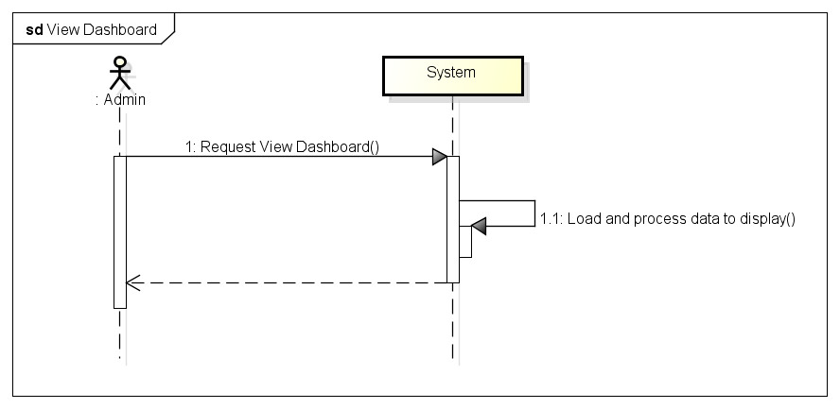*Figure 11: Sequence Diagram for View Dashboard Use case*